**Rodzon Marketing Corporation’s**

**Web Based Ordering System**

**User Manual**

**Written by:**

Carlos Daniel B. Nerez

John Michael S. Santos

**Submitted to:**

Mr. Jose Eugenio Quesada

**Overview:**

RMC-WBOS is a web-based ordering system that is designed to meet the needs of Rodzon Marketing Corporation. Primarily, the system is involved in the ordering process of finished goods. The user can list items to be ordered using the system. The system itself is composed of different parts: it has a component specifically designed to record a customer’s information, another for recording item lists, order forms, order list forms, payment and delivery information, and lastly, a log form to trace any transactions or process made inside the system.

The system has two major user types: System Admin and Regular User. Under regular user, there are three subcategories: Wholesale, Retail, and Walk-In. User types are key to the security features of the system since it grants “privileges” to a particular user. Only the system admin has absolute control over the system; all of the CRUD functionalities. On the other hand, regular users are strictly prohibited to alter and delete any records from the system.

The customer, order, order list, payment method, and delivery information/parts are all related because the customer form is the ***grandparent table*** of all other tables except for the item list form. The customer table is the *“independent variable”* in this system while all other tables, except for the item list table, is dependent onto it. In other words, creating the customer record is crucial for the system’s flow. Failed to do so may result into errors, data anomalies and data discrepancies.

**A message from the creators of RMC-WBOS:**

We would like to remind you that this system is hosted. It’s available for use by visiting this URL page: [*www.apc.csf.ph/rmc-wbos*](http://www.apc.csf.ph/rmc-wbos). Another thing that’s worth mentioning is that the system has a mobile version too. Just visit the same URL page while using your phone and you’ll see a different design into it. Nevertheless, if you wish to see, learn, and understand how we built and coded the system, feel free to visit our project repository at <https://code.google.com/p/apc-sysadd1-mi121-08/source/list> or our project wiki page at <http://projects2.apc.edu.ph/wiki/index.php/CSPROJ2_2nd_Term_2014-2015>. Go to MI-121 and click “CSPROJ2 MI121 Group 8: Team Leader: Carlos Daniel Nerez - BSIT-MI”. All the information about this project is documented at the wiki page. We hope you, the end users, would learn, enjoy, and discover new things when you use our system.

**User Hierarchy (user types)**

System Admin

Walk - In

Retailer

Wholesale

**User Roles and Privileges**

System Admin – The highest user in the Hierarchy, has all access rights and privileges. This user has the power to do CRUD functions:

**Privileges:**

* Create all types of data in the system
* Read data and information stored in the system
* Update all the data in the system
* Delete any data in the system
* Search Functions

Walk- In, Wholesale, and Retailer – These users belongs to the “regular users” group, which means, any user under this group has only limited privileges while logged on into the system.

**Privileges:**

* View specific data and information from one table to another.
* Limited search functions.

**Getting started**

To be able to access the system, go to this link: http://apc.csf.ph/rmc-wbos/



After accessing the web page, click the login tab.

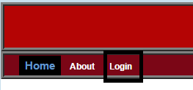

After clicking it, input the valid username and password* to the text fields provided and click the login button.

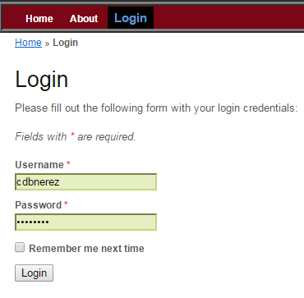

***\*valid usernames and passwords are listed in the group’s project wiki page.***

We will be using system admin’s account throughout this tutorial, thus, we input cdbnerez as the username and also as the password. The system should verify this with no errors and would redirect you to this page:

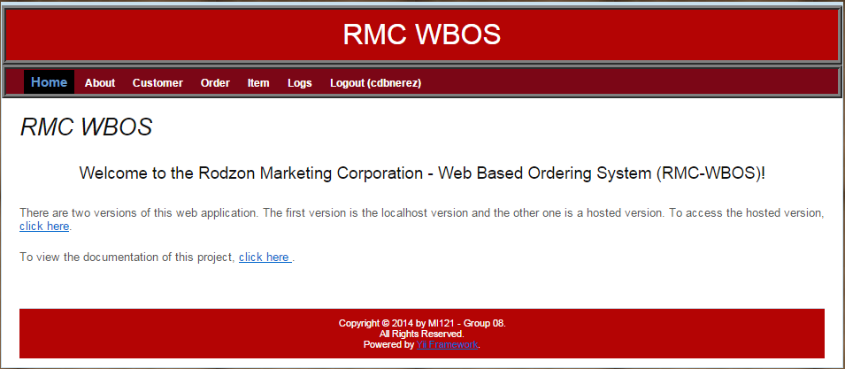

Now, using the system admin’s account, we are going to create the following:

1. New Customer record
2. New Order record
3. New Order List record
4. New Payment Method record
5. New Delivery record

To begin with, click the customer tab and a web page should show up. On the upper right hand corner, click the link that indicates “Create customer”.

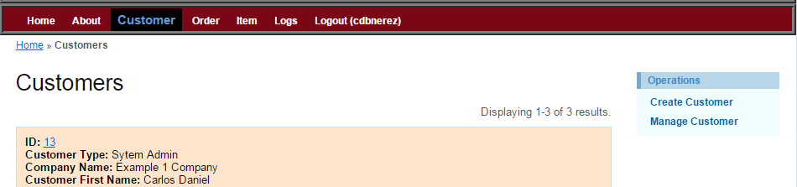

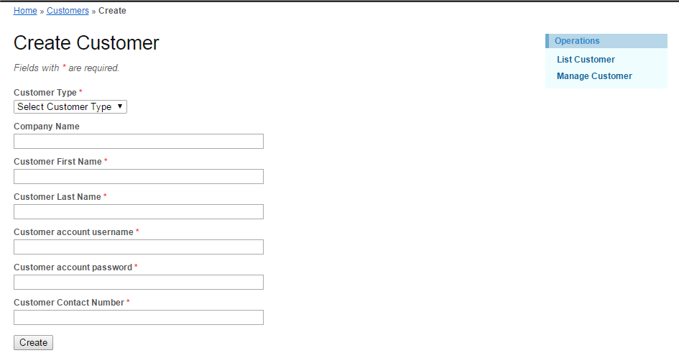

Fill out the form with valid information. On the Customer type drop box, select your preferred customer type. Please do note that the **“System Admin”** is only used for **testing purposes**. **DO NOT** create a user having a System Admin customer.

After filling out the form with valid data, click the create button and a customer information web page should popped out.

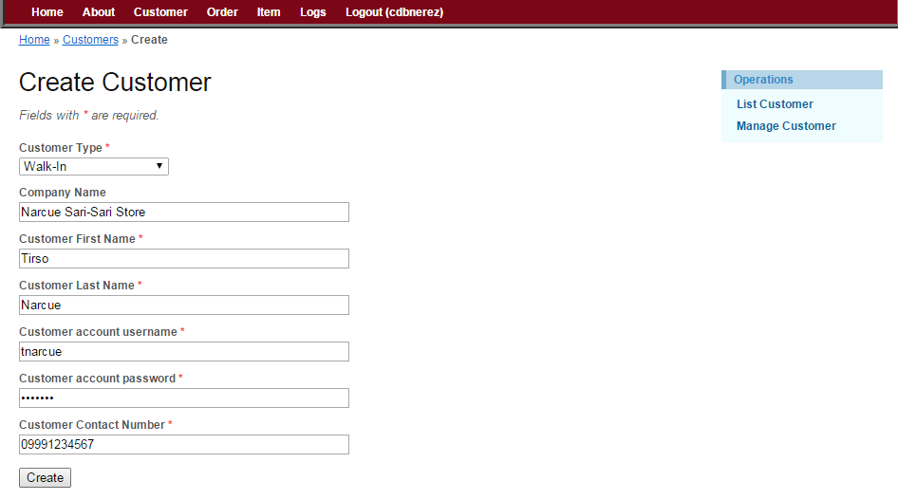

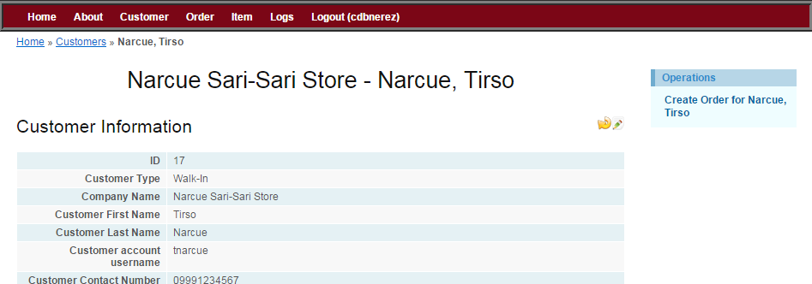

To create a new order record for this customer, click the “Create Order for Narcue, Tirso” link located at the upper right – hand corner of the web page. *Note that the link specifies the customer’s full name. This ensures that if you wish to create an order form for it, the order form would be saved under his account.*

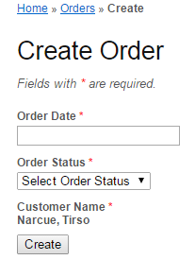

Click the order date field, a calendar would show up, click a date for this order form and then on the order status drop down box, select the “pending” status. You may also select any status if you wish to. After which, click the create button. *Note that the customer name is automatically provided for you, this ensures that this order form would be recorded under this customer account/name.*

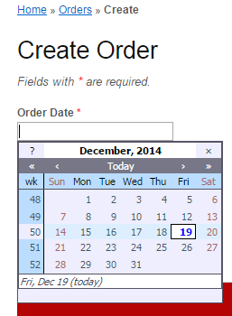

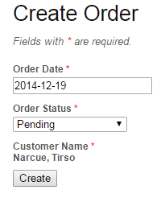

An order information web page should appear. To create an order list for this order form, click the “Create order list entry” link located at the upper right – hand corner of the web page. Disregard the link below it, it will be used later in the process.

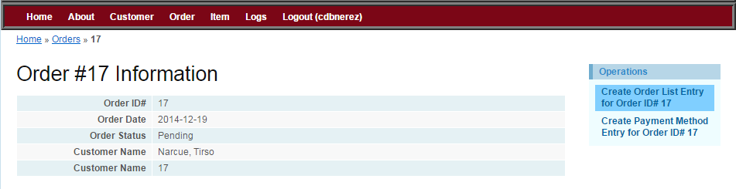

After clicking it, you should be directed to this order list form web page.

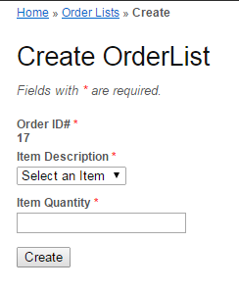

To add an item to the order list, simply select any item provided in the “Item Description” drop down box. Each item has a corresponding amount. After which, enter the quantity to be ordered. Once finished, click the create button.

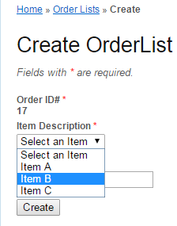

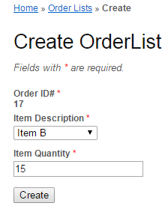

You should be redirected back to the order from web page. The difference of it however, is that the order form has the information you entered in the order list form a while ago. And, a total amount text/label field pops out that tracks the total amount to be paid in this order form.

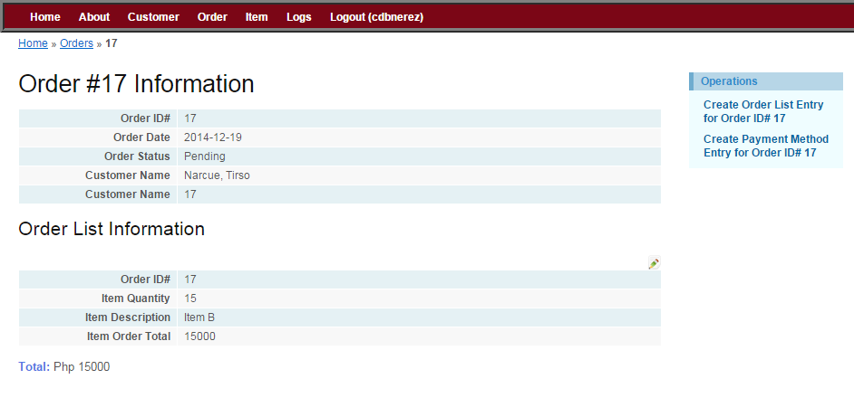

If you wish to create another order list record, just repeat the steps in creating an order list form for a particular order record that we just did earlier.

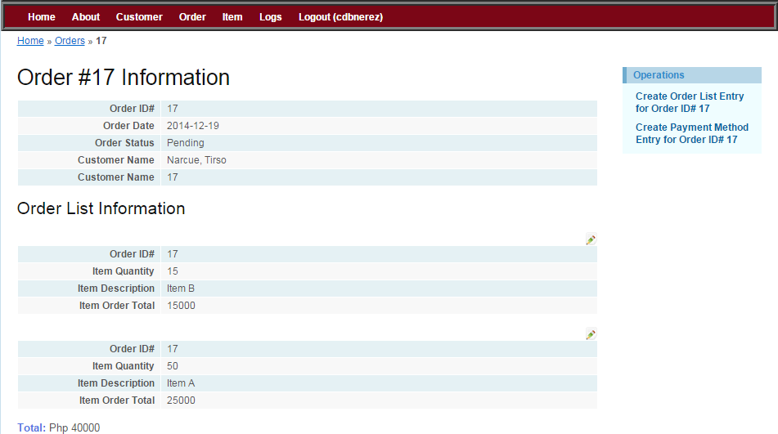

If you are satisfied with this, it’s time to create a payment method form. The payment method form is specific, meaning, only one payment method per order form. Click the “Create Payment Method Entry” link on the upper right-hand corner of the webpage to start.

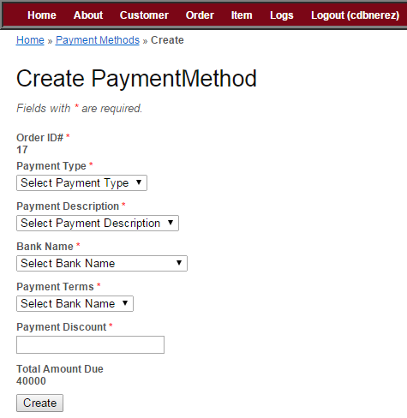

Fill out the field with valid information. After doing so, click the create button and you would be directed to the payment method information webpage. *Note that the “Total Amount Due’s” value is 40000, this was retrieved from the order table’s total amount field.*

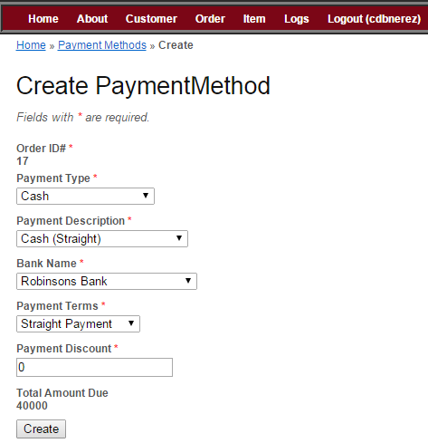

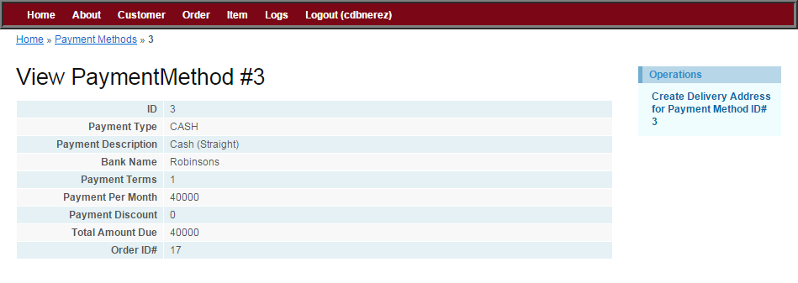

Now that you had completed creating the customer’s information, an order form, and order list form, and a payment method form, you are now 90% complete in creating your first complete order record using our RMC-WBOS system. The final step is that you will create a delivery address for this order record. To do that, simply click the “Create Delivery Address” link on the upper right-hand corner of the webpage.

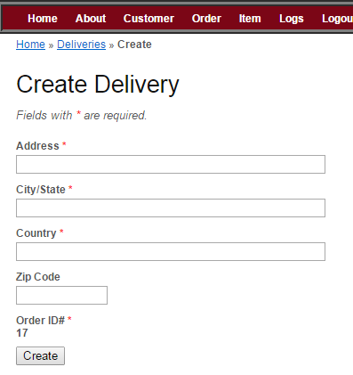

You should be prompted to this web page. Simply fill out the form and click the create button when completed.

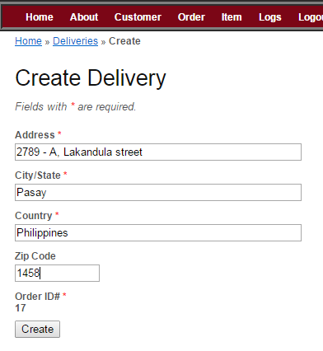

After creating the deliver information, you will be prompted to the delivery information web page. Once you’ve reached this point, you have successfully created your first complete order form using the RMC-WBOS system.

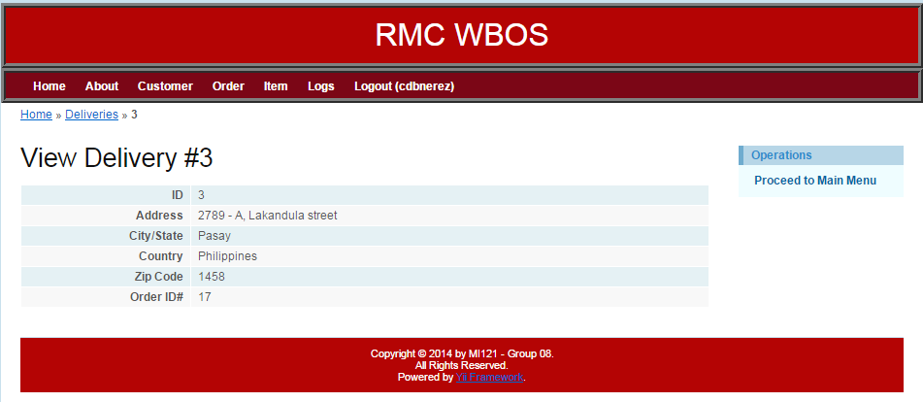

To view the record you’ve just created, select the “Proceed to Main Menu link on the upper right – hand corner of the webpage, it will redirect you to the customer information web page. Since you are using the system admin’s account, you will see all the records that were created using the system. Find the customer name of your newly created order form, and view its information.

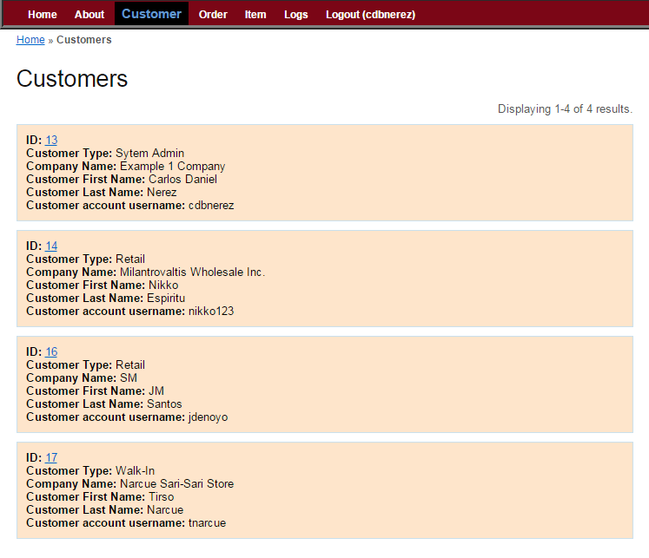

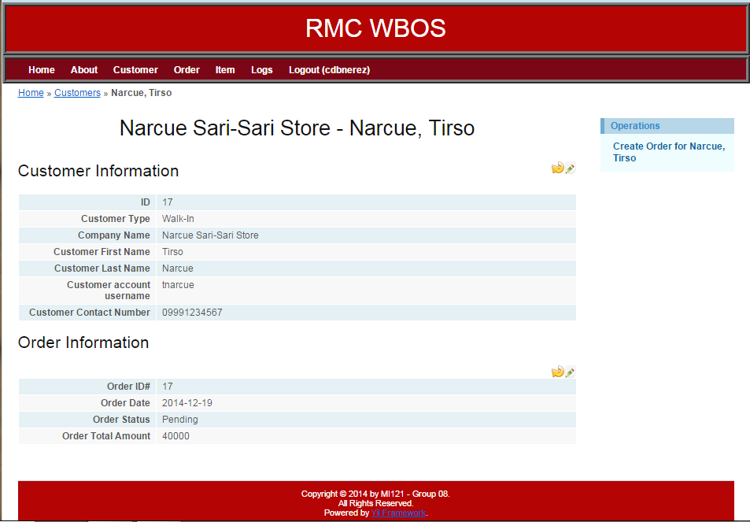

To view the order list record that you have just created, simply click the order tab in the header menu and then click the id with the customer’s name that you’ve just created earlier.

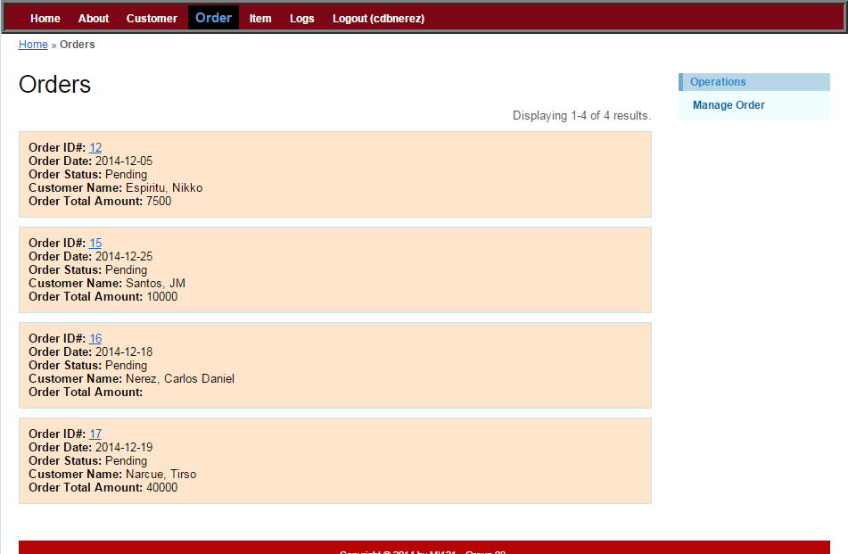

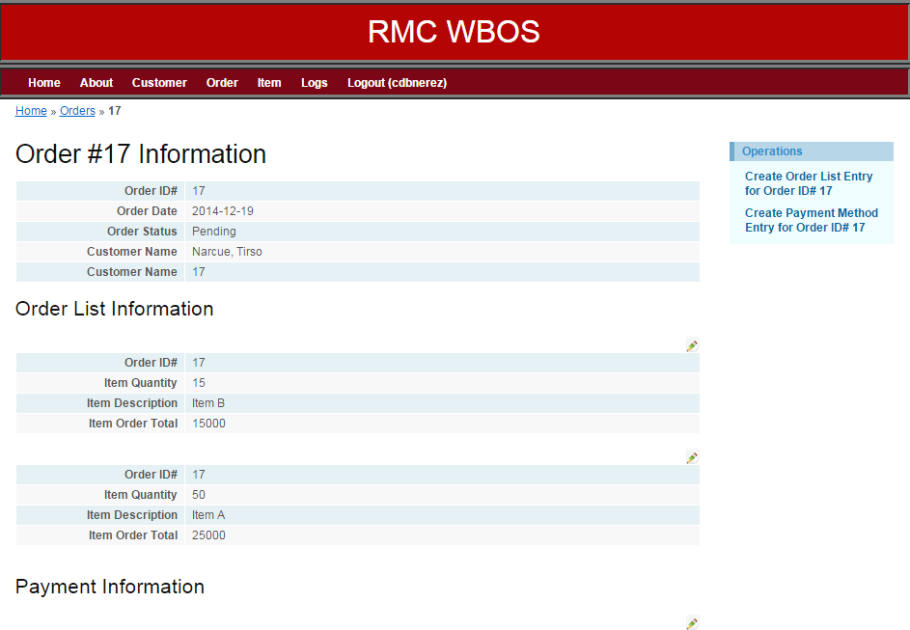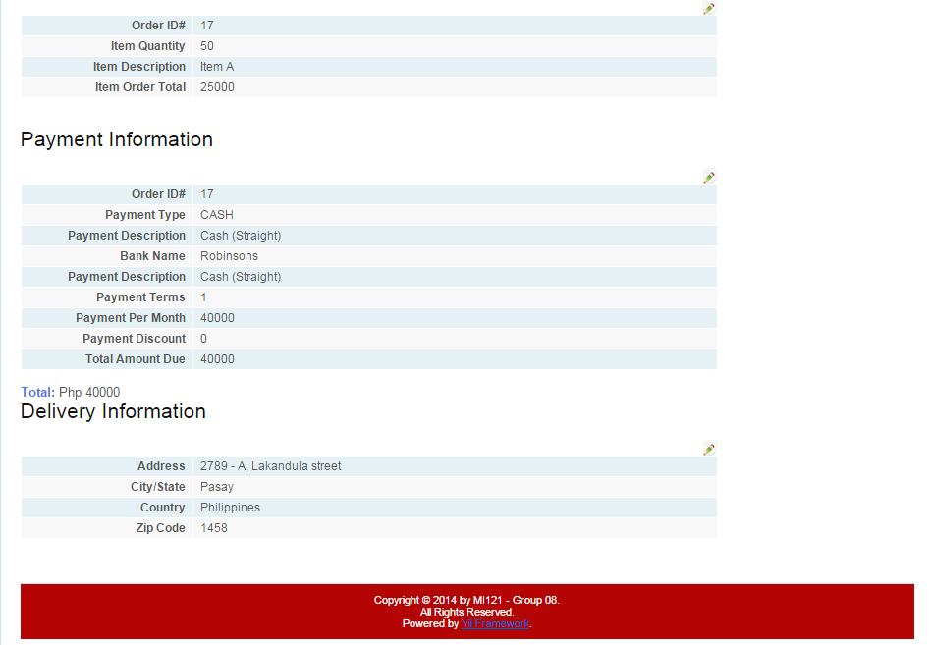

As you can see from the picture above, a more detailed view of the order has been created and recorded. Finally, all the things that we did earlier are logged. Meaning, we can trace what we did inside this system. To view this, click the logs tab from the menu bar and it should show a list of logged activities that happened inside the system.

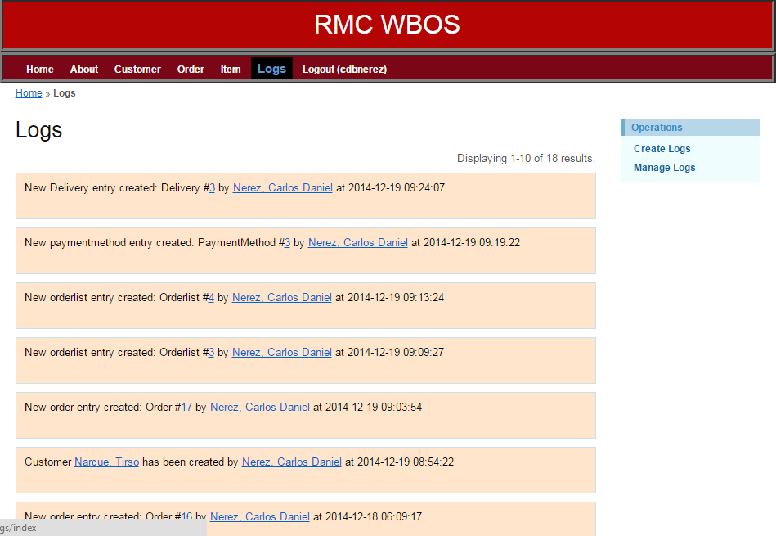

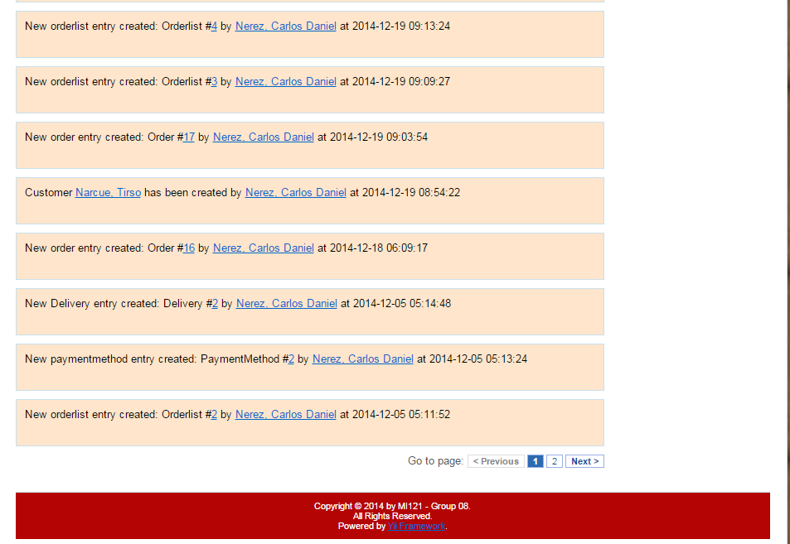

For the search function, each tab from the menu bar, except for the home, about, and logout, has a “managed” function. This managed function can only be used by the system admin. This enables search functions for that particular table.

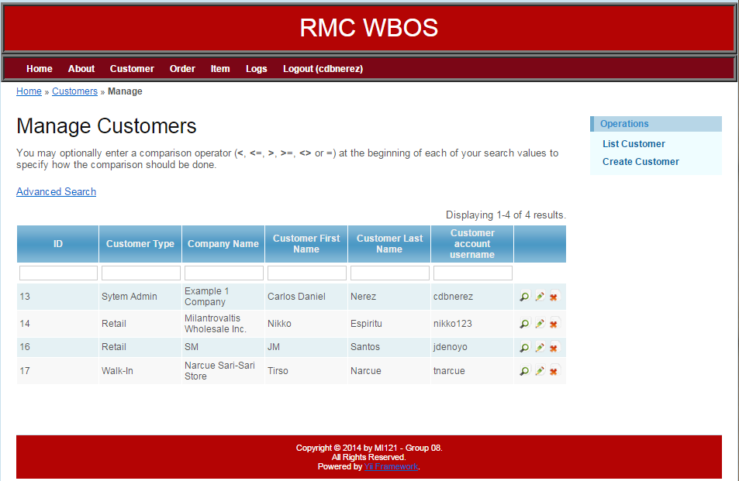

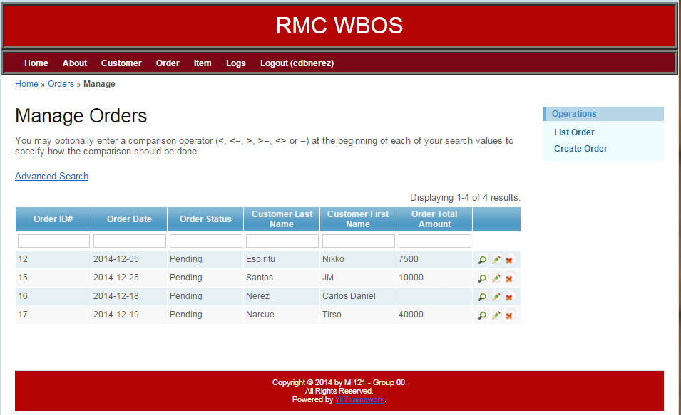

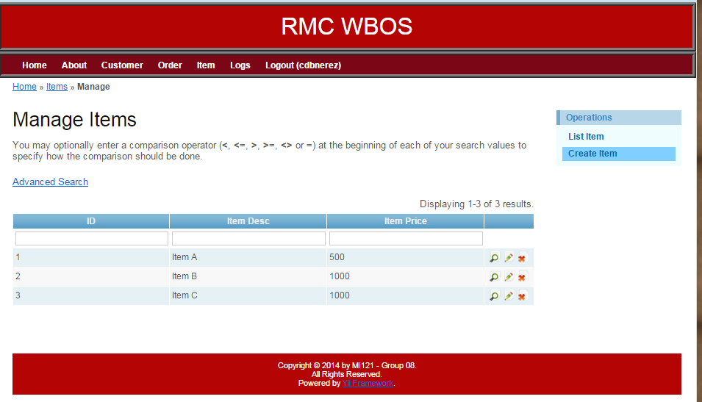

And that’s it! Thank you for using our system! We hope that it helped you a lot on your research during the entire PBL track. Good luck on your projects and God Speed!

Very truly yours,

Carlos Daniel B. Nerez, MI121  
Asia Pacific College Student  
Project Manager for the RMC-WBOS group

John Micahel S. Santos, MI121  
Asia Pacific College Student  
Head of the Web and Mobile Design for the RMC-WBOS group

Written on the 19th day of December, 2014 at Asia Pacific College, 7th Floor Library